**Crown (online business site)**

Shaibal Barman; ID: 163-15-8472; [shaibal15-8472@diu.edu.bd](mailto:shaibal15-8472@diu.edu.bd) , 01707075645

SK. Tanvir Ahmed, [tanvir15-9614@diu.edu.bd](mailto:tanvir15-9614@diu.edu.bd) , 0195535359717

**Introduction:**

As we all know now the world has become online. Everything can be done online. Even business. As a matter of fact online business has become much more efficient than offline business. People like to do their shopping or any kind of marketing through online. That’s why we have come with this online business site. People can visit this website for not only purchase but also to sell their product. As the world is progressing everything is becoming online. So in time online business will be very much successful in any kind of field.

**Methodology:**

At first user should do the registration by their own email with a return verification mail. If any user forget their password then they can reset their password .A verification email will go to their account and then they can reset their password. User can see the login page after they register. Then they can see the home page of the website. Then they can see all the product that are up for sale. When the click on the product they like the full details about the product including the original price tag of the product will be shown. If they like the product and want to buy or order the product they will be directed to another page where more information will be asked such as their location, phone number, billing options. Every customer that want to buy anything will have to fill up all the information. User can see some more option when they press their account avatar. They can update their account password from the change password screen. They can Update their old password with a strong verification email. User can delete their own account from the account screen. A logout button will be provided to logout from the webpage.

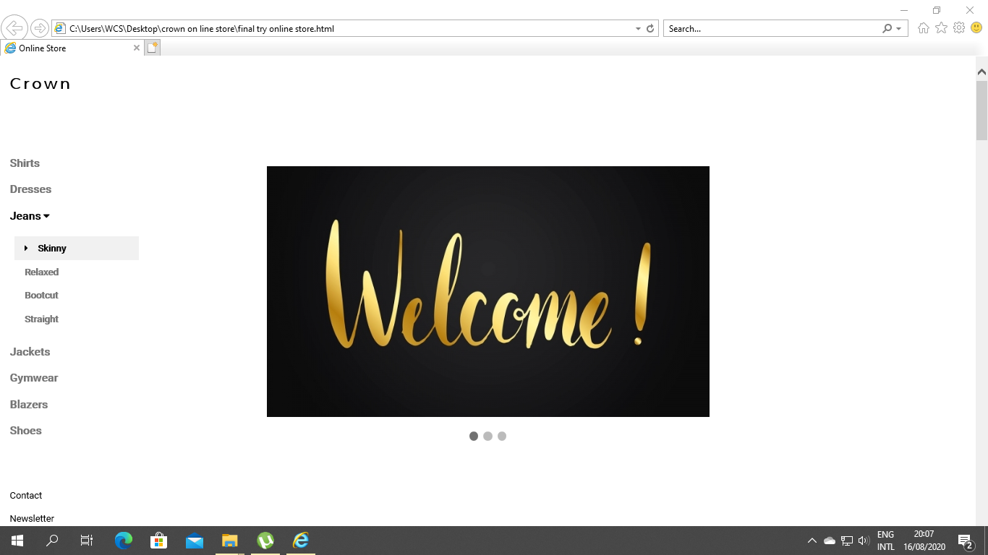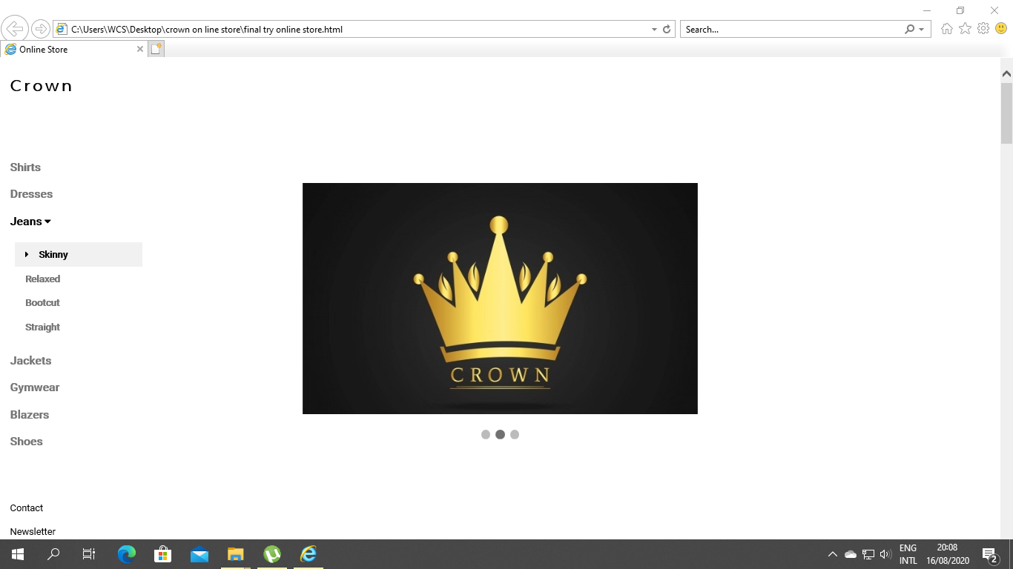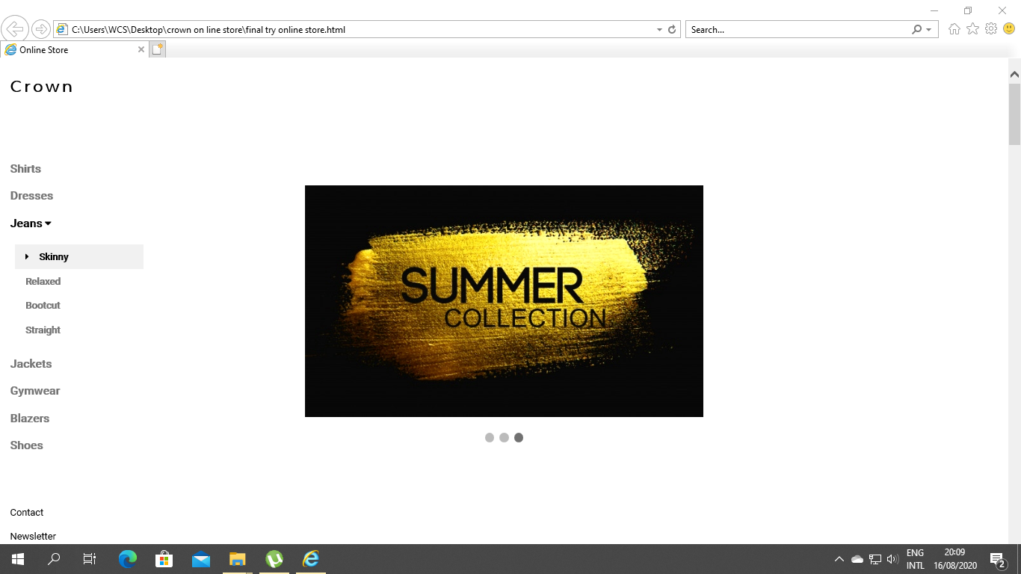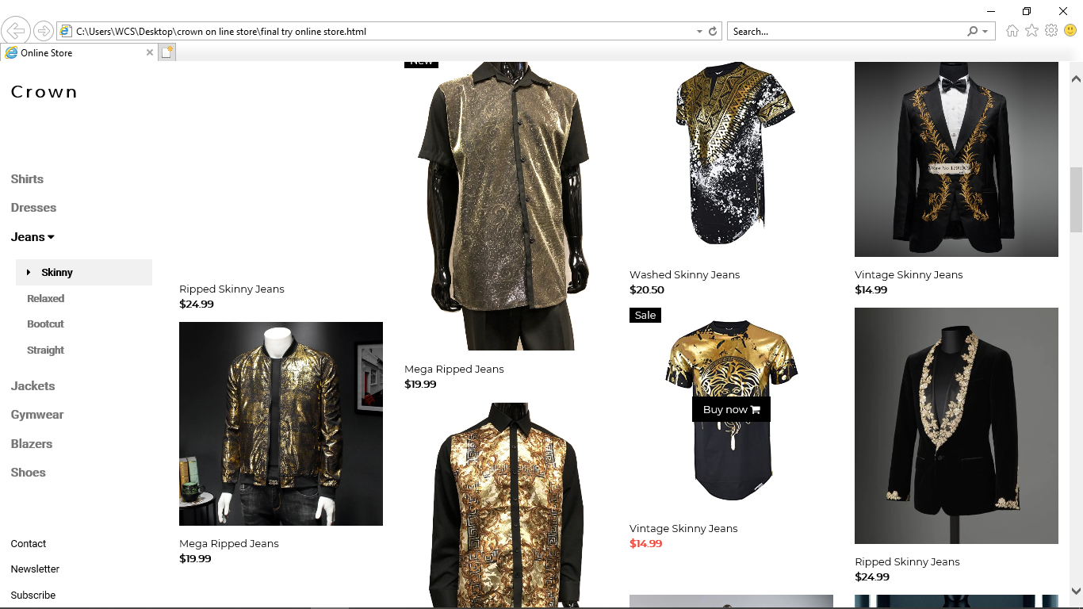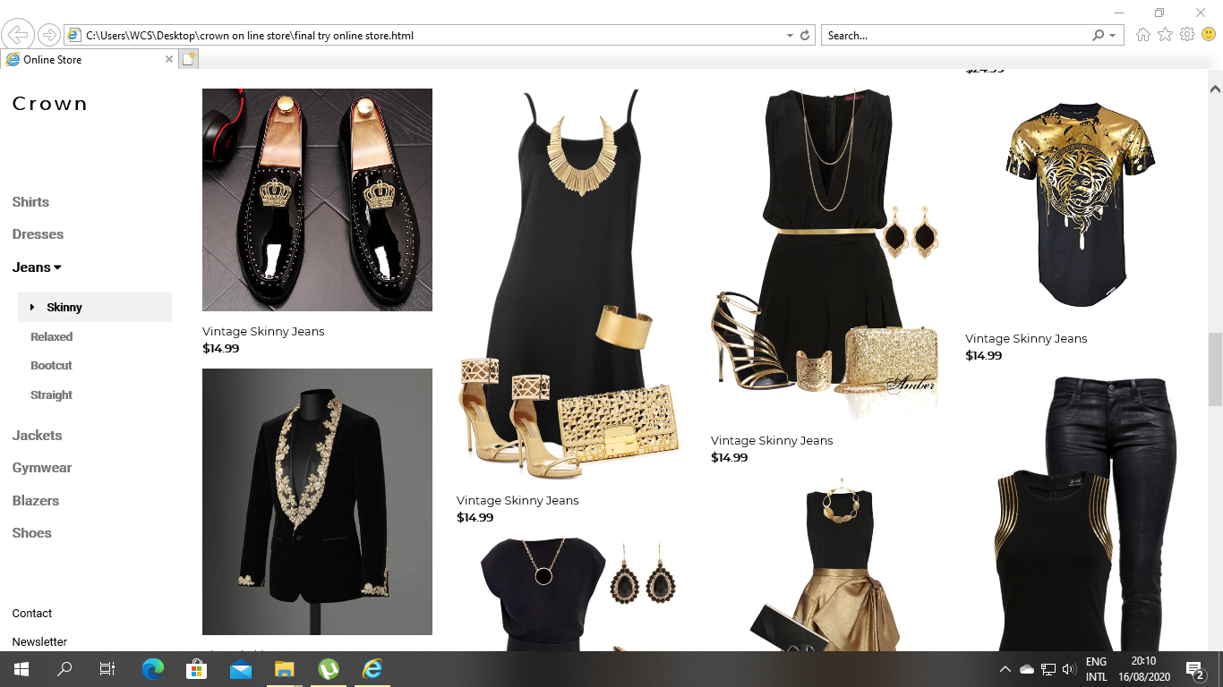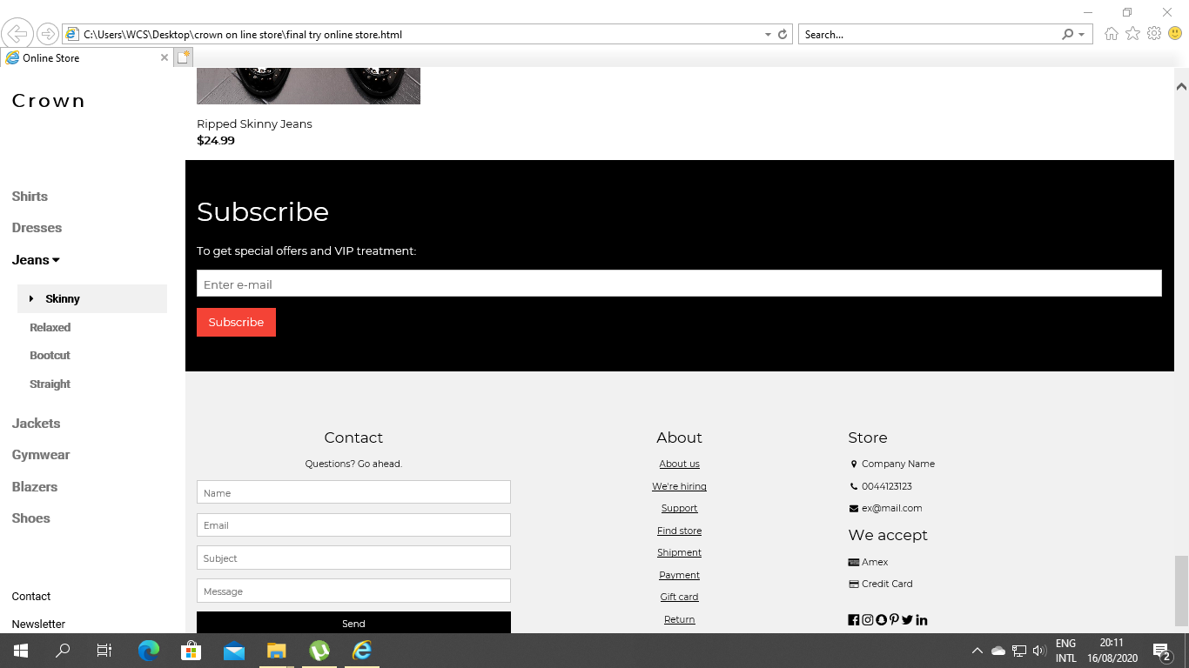

**Technology :**

HTML , CSS , Java Script

**Final Result :**

After completing the project webpage we tried to use all the features that we added and it is working properly. And also, we can add any type of product such as cloths , gadget , food etc.